**Who is the domain registrar of** [**www.manipal.edu**](http://www.manipal.edu)**?**

**What is the domain creation date?**

**What is the expiration date of the domain?**

**Identify the name servers associated with the domain.**

**Is there any contact email provided for administrative or technical support?**

**What country is the domain registered in?**

INDIA

**Run a WHOIS query for example.com and check if the registrant’s details (name, address, email) are visible.**

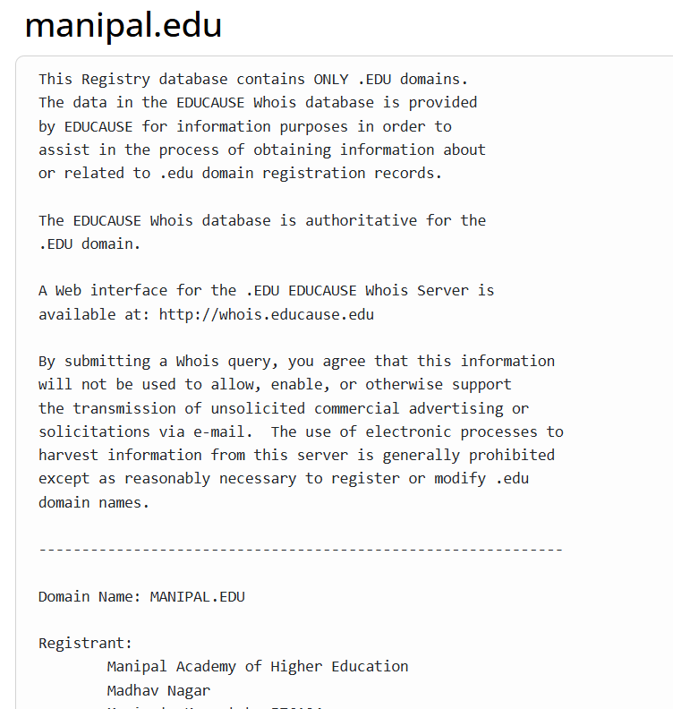

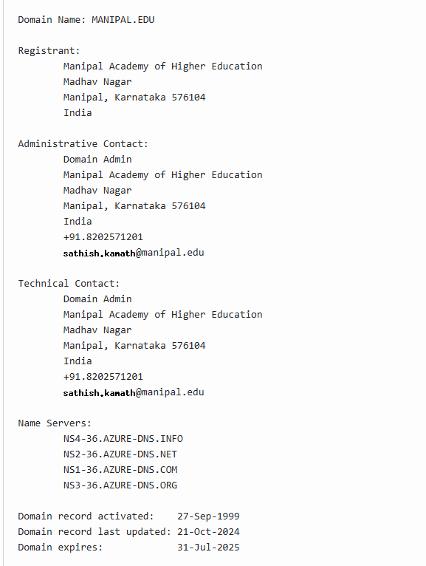

**If privacy protection is enabled, what information is displayed instead of actual owner details?**

Address, technical assistant and his contact details.

**What are the security implications of exposing or hiding data?**

Exposing the data will lead to phishing attacks, brute force attacks and social engineering attacks.

Hiding the details will not cause any of these attacks but will question the legitimacy of the website.

**Look for Name Server (NS) records and associated domains.**

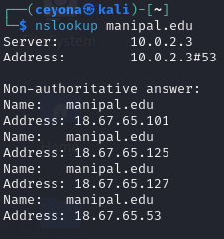

**what are the different methods to find the subdomain using both passive and active methods**

For passive methods we can use google dorking where as for active methods we can use gobuster,ffuf etc

**Identify CMS (WordPress, Joomla, etc.) and frameworks used.**

Manipal.edu is using Adobe Experience Manager

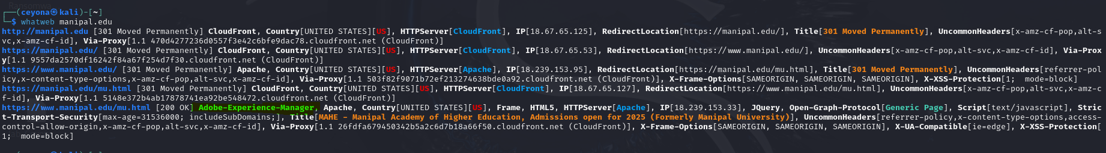

**compare whatweb and wappalyzer**

whatweb is a command line tool where as wappalyzer is a browser extension

**Fetch the HTTP Header ( Many methods are available). Identify the tools used to find HTTP Header details**

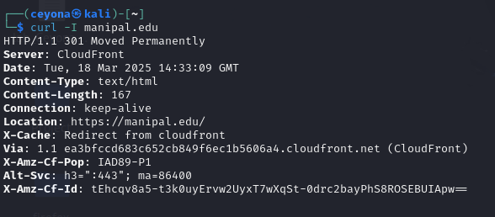

**Check whether domain have firewall installed or not**

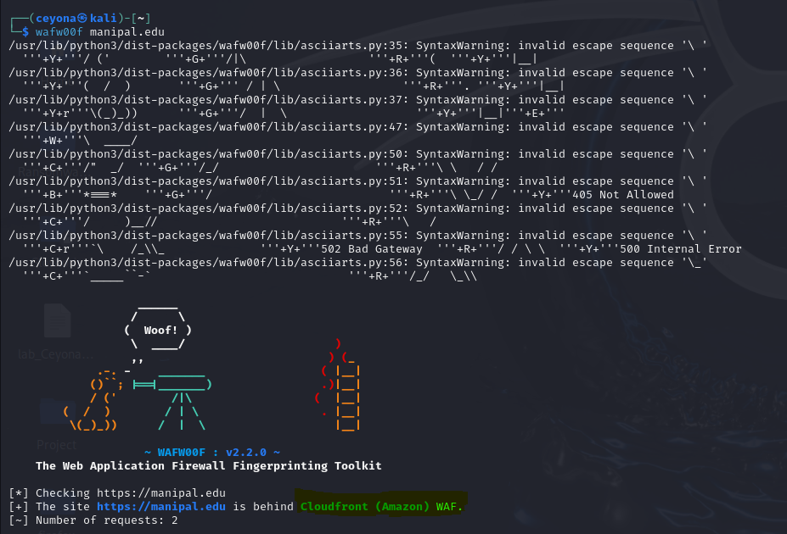

**do they have load balancer**

CloudFront acts as the load balancer

**Search for exposed environment configuration files**

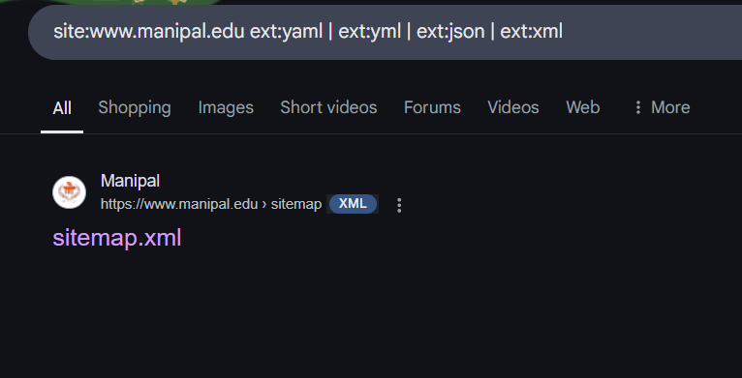

If the plan doesnt work, change the plan but not goal.